Practical No 3 Containerization Using Docker
Aim: To provide students with a thorough understanding of Docker and Docker Compose, enabling them to containerize applications, manage multi-container setups, and apply best practices for containerization in real-world scenarios.

Objectives
By the end of this practical, you will be able to:
- Explain containerization and how it differs from traditional virtualization.
- Install Docker Desktop on Windows or macOS.
- Pull and run containers from Docker Hub, and manage them using core Docker CLI commands.
- Write a Dockerfile to build a custom image for a simple application.
- Run a custom container, map ports, and access the application from a browser.
- Use volumes/bind mounts to persist and share data with a container.
- Use Docker Compose to run a small multi-container application.

Background Theory
Containerization is a lightweight form of virtualization that packages an application together with all its dependencies (libraries, binaries, configuration) into a single unit called a container. Unlike a virtual machine, a container does not include a full guest operating system — instead, containers share the host machine's OS kernel, making them much smaller and faster to start.

Aspect | Virtual Machine | Container
Includes full guest OS | Yes | No (shares host kernel)
Startup time | Minutes | Seconds
Typical size | GBs | MBs
Isolation level | Strong (hardware-level) | Process-level
Managed by | Hypervisor | Container engine (e.g., Docker Engine)

Key Docker concepts:
Image: A read-only template containing an application and its dependencies (like a blueprint).
Container: A running (or stopped) instance of an image.
Dockerfile: A text file with instructions used to build a custom image.
Docker Hub: A public registry of pre-built images (e.g., nginx, python, ubuntu).

Volume: A mechanism to persist data generated by containers, or share files between host and container.
Docker Compose: A tool to define and run multi-container applications using a single YAML file.

Prerequisites / Requirements

Requirement | Details
Free disk space | At least 10 GB
RAM | At least 8 GB recommended
Internet connection | Required to download Docker Desktop and images
Windows only | Windows 10/11 64-bit (Pro, Enterprise, or Education for Hyper-V, or Home with WSL2)
macOS only | macOS 12 (Monterey) or later recommended
Admin/sudo access | Required to install Docker Desktop

Apple Silicon (M1/M2/M3/M4) and Intel Mac users: Docker Desktop supports both architectures natively — no special workaround is needed, unlike VirtualBox. Just download the correct build (Apple Silicon or Intel) as instructed below.

Part A — Installing Docker Desktop

Windows Instructions
    - Enable WSL2 (Windows Subsystem for Linux), which Docker Desktop uses as its backend on Windows: Open PowerShell as Administrator and run:
wsl --install
Restart your computer if prompted.
    - Go to https://www.docker.com/products/docker-desktop/ and click Download for Windows.
    - Run the downloaded Docker Desktop Installer.exe.
    - In the setup dialog, ensure "Use WSL 2 instead of Hyper-V" is checked, then click Ok to install.
    - Once installation finishes, click Close and restart if prompted.
    - After restart, Docker Desktop should launch automatically. Accept the service agreement.
    - Wait for the whale icon in the system tray to stop animating — this means the Docker Engine has started.
    - Open Command Prompt or PowerShell and verify installation:
docker --version docker run hello-world

macOS Instructions
- Go to https://www.docker.com/products/docker-desktop/.
- Click Download for Mac, and choose the correct chip version: Apple Silicon for M1/M2/M3/M4 Macs
Intel Chip for older Intel-based Macs (Check your chip under Apple menu → About This
Mac.)
- Open the downloaded Docker.dmg file.
- Drag the Docker icon into the Applications folder.
- Open Docker from Applications (or Launchpad). If macOS shows a security warning, go to System Settings → Privacy & Security and click Open Anyway.
- Accept the service agreement, and enter your Mac password if prompted to grant privileged access.
- Wait for the whale icon in the menu bar to show "Docker Desktop is running."
- Open Terminal and verify installation:
docker --version docker run hello-world
Expected result (both OS): The hello-world command downloads a tiny test image and prints a message beginning with "Hello from Docker!" — confirming Docker can pull images, create containers, and run them.

Part B — Core Docker CLI Commands
Run the following commands in Command Prompt/PowerShell (Windows) or Terminal (macOS)
— they are identical on both platforms.
- Pull and run an Nginx web server container in the background:
docker run -d -p 8080:80 --name my-nginx nginx
-d runs it detached (in the background)
-p 8080:80 maps host port 8080 to container port 80
--name my-nginx gives the container a friendly name
- Open a browser and visit http://localhost:8080 — you should see the "Welcome to nginx!" page.
- List running containers:
docker ps
- List all containers (including stopped ones):
docker ps -a
- View logs from the container:
docker logs my-nginx
- Open an interactive shell inside the running container:
docker exec -it my-nginx /bin/bash

Run ls /usr/share/nginx/html inside the container, then type exit to leave.
- Stop and remove the container:
docker stop my-nginx docker rm my-nginx
- List downloaded images and remove one if desired:
docker images docker rmi nginx

Part C — Building a Custom Image with a Dockerfile
You will containerize a very simple Python web application.

Create the project folder and files
Windows (Command Prompt):
mkdir docker-practical cd docker-practical
macOS (Terminal):
mkdir docker-practical cd docker-practical
Using a text editor (VS Code recommended, or Notepad/TextEdit), create the following two files inside docker-practical:

app.py
from flask import Flask app = Flask( name )

@app.route("/") def home():
return "Hello from inside a Docker container!"
if name == " main ": app.run(host="0.0.0.0", port=5000)

requirements.txt
flask

Dockerfile (no file extension)
# Use an official lightweight Python image as the base FROM python:3.11-slim

# Set the working directory inside the container WORKDIR /app

# Copy dependency list first (better build caching) COPY requirements.txt .

# Install dependencies
RUN pip install --no-cache-dir -r requirements.txt

# Copy the rest of the application code COPY . .

# Document which port the container listens on EXPOSE 5000
# Command to run when the container starts CMD ["python", "app.py"]
Tip (both OS): Make sure Dockerfile has no file extension (not Dockerfile.txt). On Windows, if using Notepad, choose Save as type: All Files and type the name Dockerfile exactly.
  - Build the image
From inside the docker-practical folder, run (same command, both OS):
docker build -t my-flask-app .
-t my-flask-app tags the image with a name.
. tells Docker to use the current folder as the build context (where the Dockerfile is).
Watch the build steps execute in order, matching the Dockerfile instructions.
  - Run the custom container
docker run -d -p 5000:5000 --name flask-container my-flask-app
Open a browser and go to http://localhost:5000 — you should see:
Hello from inside a Docker container!
  - Clean up (optional, before moving on)
docker stop flask-container docker rm flask-container

Part D — Using Volumes to Persist/Share Data
Volumes let you share files between your host machine and a container, or persist data beyond a container's lifecycle.
- Stop and remove the previous container if still running (see 6.4).
- Run the Flask container again, this time mounting your local project folder into the container so code changes reflect without rebuilding:
Windows (Command Prompt, run from inside docker-practical):

docker run -d -p 5000:5000 --name flask-container -v "%cd%":/app my-flask-app
macOS (Terminal, run from inside docker-practical):
docker run -d -p 5000:5000 --name flask-container -v "$(pwd)":/app my-flask-app
- Edit app.py in your text editor — change the returned message string, e.g., to "Hello, updated container!", and save.
- Restart just the container process to pick up the change:
docker restart flask-container
- Refresh http://localhost:5000 in your browser and confirm the updated message appears
— demonstrating that the host folder is live-mounted into the container.
- Stop and remove the container when done:
docker stop flask-container docker rm flask-container

Part E — Multi-Container Apps with Docker Compose
Docker Compose lets you define and run multiple related containers (e.g., a web app + a database) together using one YAML file.
- In the docker-practical folder, create a new file named docker-compose.yml:
version: "3.9" services:
web:
build: . ports:
- "5000:5000"
volumes:
- .:/app redis:
image: redis:alpine ports:
- "6379:6379"
This defines two services: your Flask app (web, built from your Dockerfile) and a Redis in-memory database (redis, pulled from Docker Hub).
- Start both containers together (same command, both OS):
docker compose up -d
- Verify both containers are running:
docker compose ps
- Visit http://localhost:5000 again to confirm the web service still works, now running under Compose.

- Stop and remove both containers together:
docker compose down

Observation / Screenshot Checklist
Capture and paste screenshots of:
- docker run hello-world output confirming successful installation.
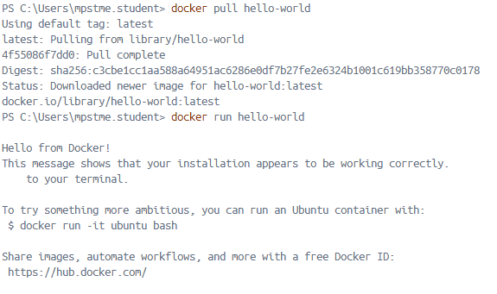
- Browser showing the Nginx welcome page at localhost:8080.
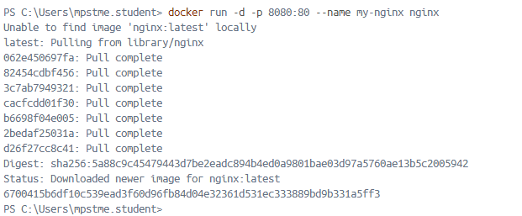
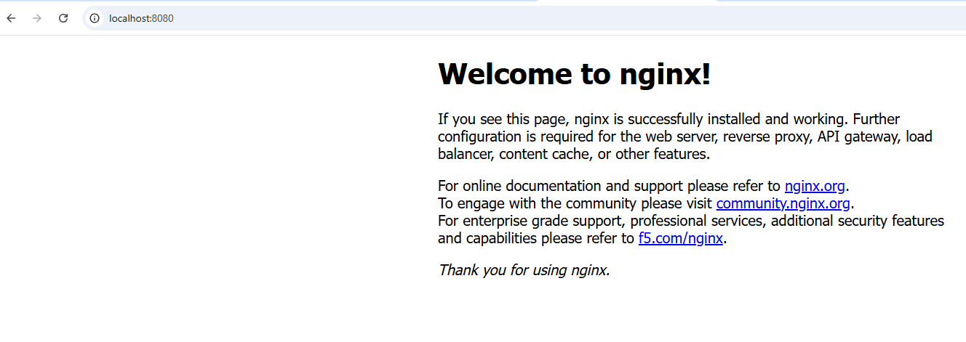

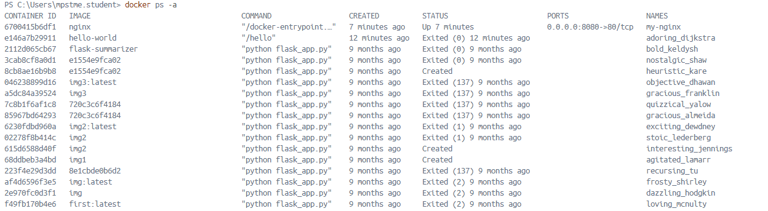

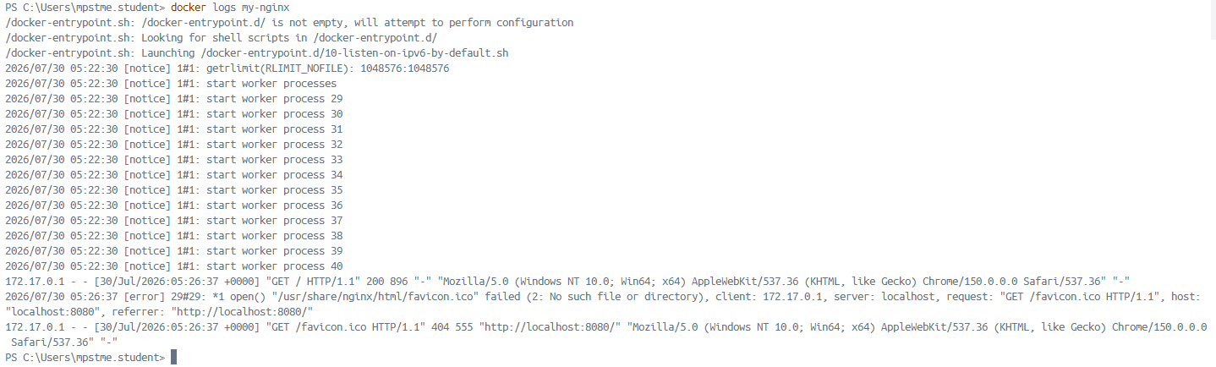

- docker ps output listing your running container(s).
- Terminal output of docker build -t my-flask-app . completing successfully.
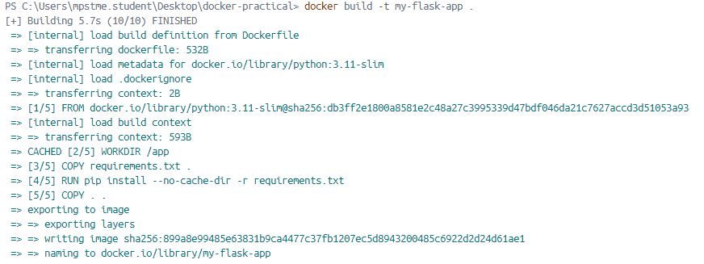
- Browser showing your custom Flask app's message at localhost:5000.
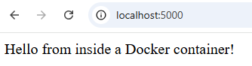
- Browser showing the updated message after editing app.py with the volume mounted.

- docker compose ps showing both web and redis services running.
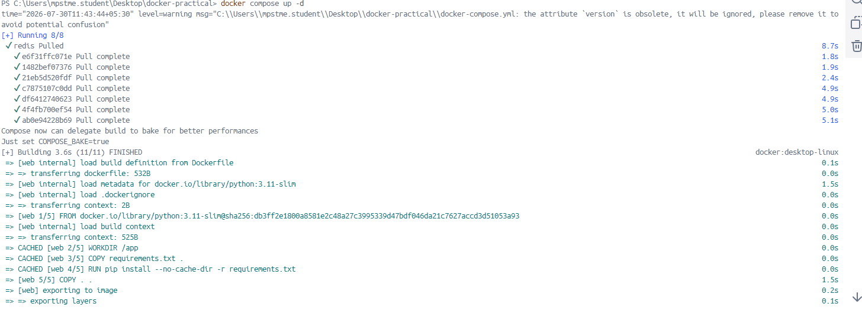

11. Conclusion
In this practical, you experienced the full containerization workflow: installing Docker Desktop, running pre-built containers from Docker Hub, writing a Dockerfile to package your own application into a custom image, persisting/sharing data using volumes, and orchestrating a small multi-container application with Docker Compose. Together, these skills demonstrate how containerization enables lightweight, portable, and reproducible application deployment compared to traditional full-OS virtualization.

